Game Concept & Design Document

Shoot The Guys

By

Full Name: Steven Impson
Student ID: 32199883
Unit/Semester: ICT241 - Game Software Design/Semester One 2014
School:
Murdoch University

Game Design Document Contents

1 Introduction 1
2 Concept Document 2
2.1 Title Page 2
2.2 Credit Page 2
2.3 Sign-Off 3
2.4 Introduction 3
2.5 Game Analysis 3
2.6 Game Atmosphere 5
2.7 Game Play 5
2.8 Key Features 6
2.9 Selling Features 6
3 Design Document 7
3.1 Design Version 7
3.2 Design Guidelines 7
3.3 Game Design Definitions 7
3.4 Player Elements 7
3.4.1 Player Definition 7
3.4.2 Player Properties 8
3.4.3 Player Rewards (Power-ups & Pick-ups) 9
3.4.4 User Interface (UI) 9
3.4.5 Heads up Display (HUD) 9
3.4.6 Player View 9
3.5 Antagonistic Elements 9
3.5.1 Antagonistic Definitions 10
3.5.2 Antagonistic Properties 10
3.5.3 Antagonistic List 10
3.5.4 Artificial Intelligence (AI) 10
3.6 Global Game Elements 10
3.7 The Story 10
3.7.1 The Story Copy 10
3.8 Concept Art 11
3.9 Level Design 11
3.9.1 Level Copy 11
3.10 Audio & Sound F/X 11
3.11 Game Architecture 11
3.11.1 Game Architecture Overview 12
3.11.2 Architecture Copy 12
3.11.3 How to play Copy 12
4 Appendix A 13
4.1 Taxonomy 13
4.2 Genre 13
4.3 Game Elements 14
4.4 Content 14
4.5 Theme 14
4.6 Style 14
Appendix B 15

Introduction

Shoot The Guys is a side scrolling space shooter in the style of R-Type or Darius. It allows players to take control of a spaceship which can fly about and shoot down various alien adversaries with a varied arsenal of weapons.

Concept Document

Title Page



Credit Page

Document Purpose: | Game Design Document
Document Version: | 1.0
Working Title: | Shoot The Guys
Game Concept: | Side scrolling shooter
Game Document Author: | Steven Impson

Sign-Off

Game Design Sign-off

Lead Designer: | Steven Impson
Lead Programmer: | Steven Impson

Introduction

Shoot The Guys is a 2 dimensional side scrolling shooter, in the style of R-Type, Darius or Gradius. Similar to other games of its genre, it is set in space and features various alien and space themed adversaries for the player to shoot through to reach the end of the level.

After destroying enough adversaries, the player is rewarded with upgrades for their weapons, which come in useful when enemies become more formidable later in the level.

Game Analysis

This is a general overview of the game.

Game Description
Genre: | - Side-scrolling space shooter
Game Elements: | - Shooting  - Maneuvering to dodge bullets  - Powering up weapons  - Blasting through waves
Game Content: | - Action
Theme: | - Science Fiction
Style: | - Similar to old side scrolling shooters like R-Type
Game Sequence: | - Linear, level by level
Player: | - One
Game Reference
Game Taxonomy: | - Non-fiction science fiction scrolling shooter
Player Immersion: | - Tactical, adrenaline, visual
Reference: | - Similar to Darius and R-Type
Game Technical
Technical From: | - 2 dimensional graphics
View: | - Side view
Platform: | - Construct2
Device: | - PC based browser
Game Sales
Consumer Group: | - Older people who enjoyed shooters of this style in the past, as well as younger people who may enjoy the action gameplay
Payment: | - N/A
Estimated Price: | - N/A
Device Support List | - PC based browser

Game Atmosphere

- Game is set in space, the character controlling a spaceship with various weapons, and facing adversaries of various types of alien and opposing spaceships.

Game Play

Player will open the game, and can choose to view the credits or controls if they are unfamiliar with the game, by pressing F1 and F2 respectively.
They can press Enter to go straight into the action.

While playing the player can move their spaceship up, down left and right, as well as shoot. They must dodge moving enemies and the bullets they shoot. Each time they are hit, their shields will reduce from the 5 that they begin the game with. After 5 hits the player will explode, and will need to retry the level.

While shooting down adversaries, occasionally a bullet powerup will appear, which the player can move to collect, and this will change the way their bullets fire by adding more bullets, increasing their power or making them fire in different directions to make it easier to defeat more enemies.

The player can make the choice to defeat enemies or dodge around the, and this will become important in later stages of levels where enemies may appear which require a large amount of shots to destroy.

Key Features

- Initially only has one level, but planning for 5 total. Can gradually add more levels in future
- Currently features 5 different enemy types with their own movement, shooting patterns and strengths.
- Currently enjoyable for about 5 minutes but this will be extended with further levels.
- Replayable to gain a greater score
- Features appropriate music and sound effects to accompany gameplay.
- One Player
- May incorporate an online leaderboards

Selling Features

- See Key Features

Design Document

Game Design Definitions

Player enters the game and is presented with a menu. They can press F1 to get information regarding controls, F2 to view the game’s credits, and Enter to start the game when ready.
The player has 5 shield points, which are depleted when hit by an enemy or their bullets. The player will enter a short period of invulnerability after being hit, to prevent the player losing all of their health points in a single encounter.

If they lose all of their health points they must start the level from the start.

The player must aim to reach the end of the level without having their ship destroyed, by shooting and avoiding enemies and their bullets.

Player Definition

- Player is able to move their ship up, down, left and right on the 2 dimensional plane.
- They can fire bullets corresponding to their bullet powerup level.
- They begin the level with 5 shield points which are depleted when colliding with an enemy ship or bullet

Player Properties

- Health/Shields
- Current bullet power up

Player Rewards (Power-ups & Pick-ups)

Bullet powerup – increases the power and changes the behavior of the player’s attacks.

User Interface (UI)

This game requires only directional inputs, and a single action input. Currently playable on a keyboard with directional keys and Ctrl, but could be adapted for use with a game pad or touch based devices, using either an on screen joystick, tilt controls, or direct thumb movement, and tapping to fire using multitouch capable devices.

Heads up Display (HUD)

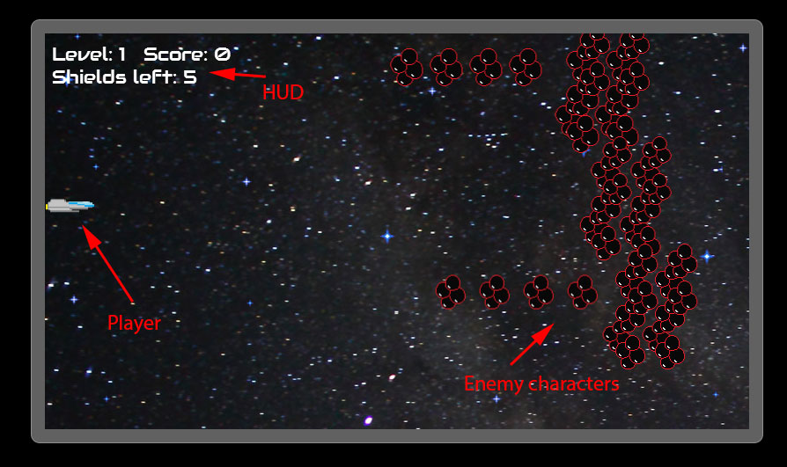

Player View

See screenshot above

Play field constantly scrolls across, with background starfields and stars using a parallax effect to imply depth while moving. Player can move anywhere within the play field window, camera will scroll without regard for how the player is moving.

Antagonistic Elements

Bubble enemy – moves in a straight line towards player, often in walls that the player must shoot through. As many of these enemy types appear, it can be advantageous as they may create bullet pickups for the player

Tentacle enemy – moves with a vertical sine wave motion, firing bullets to the left

Spaceships – move in various sine wave motions, vertical and horizontal and at different speeds depending on colour. Fires bullets to the left regularly.


Ghostly visage – a large enemy that moves at differing speeds to the left of the screen. As it does not move vertically it is easy to avoid, and it has a large amount of hits required to defeat. Players can choose to shoot it or dodge it altogether.

Enemy bullet – Fired by enemies to the left to hurt player shield

Antagonistic Definitions

Any element that when touched by the player ship, will reduce their shield count by 1. Can be destroyed by player with bullets.

Global Game Elements

In this section it is important to describe the boundaries, neutral objects, camera views and scale of the world.

Neutral game world objects can be things like a static background, objects that do not interact with the player or antagonistic elements.

The Story

There is no specific story to this game, the player is simply tasked with surviving.

Audio & Sound F/X

Menu music – played in the menu
Level music – played during gameplay
Shoot effect – played whenever a player fires a bullet
Impact effect – played when a player bullet collides with an enemy
Hurt effect – plays when player ship collides with an enemy or an enemy bullet
Victory effect – played when player successfully reaches the end of a level
Powerup effect – played when a player collides with a pickup object

Game Architecture

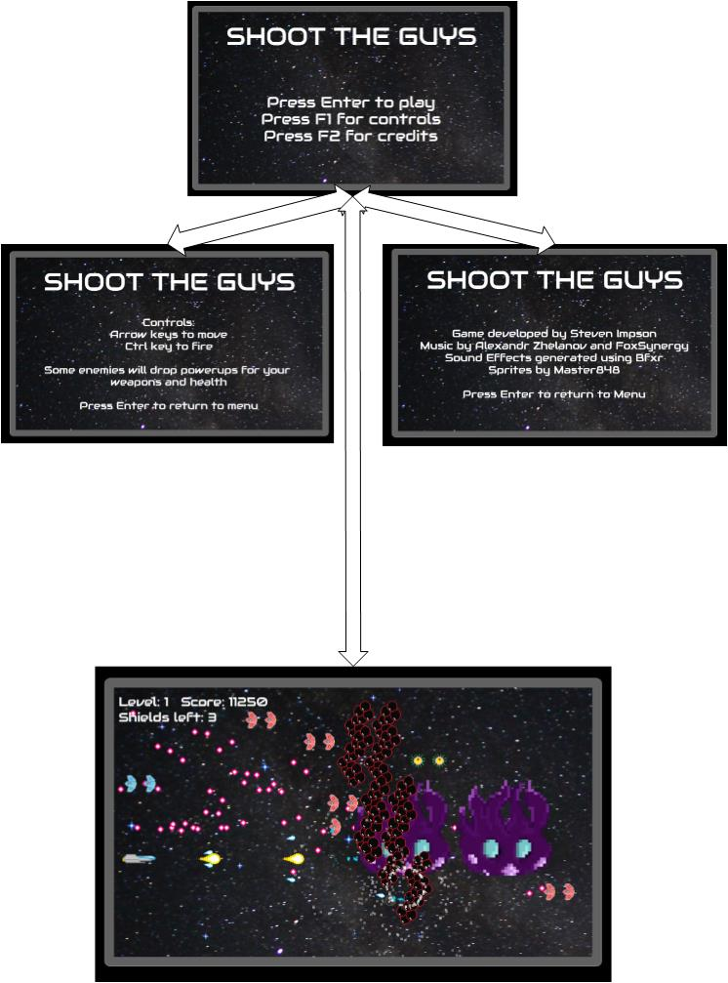

How to play Copy

Controls:
Arrow keys to move
Ctrl key to fire

Some enemies will drop powerups for your weapons and health

